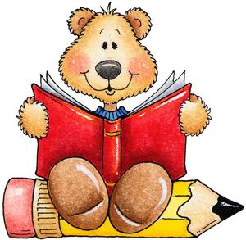List 1
the | to | and | he | a
I | you | it | of | in
was | said | his | that | she
for | on | they | but | had
at | him | with | up | all
List 2
look is her there some out be have go we am then little down do a could when did what so see not were
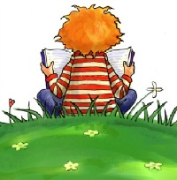List 3
get them like one this my would me will yes big went are came if now long no came ask very am over your its

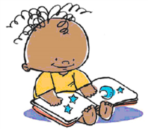List 4
ride into just blue red from good any about around want don’t how know right put too got take where every pretty jump green four
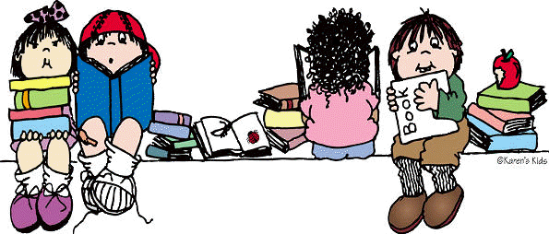List 5
away old by their here saw call after well think ran let help make going sleep brown yellow five six walk
two or before eat
List 6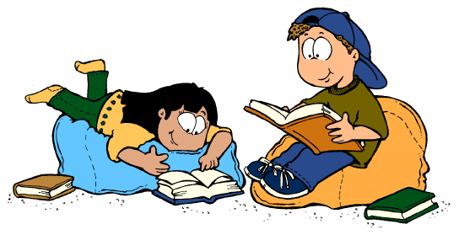
again play who been may stop off
never seven eight cold today fly myself round tell much keep give work first try new must start

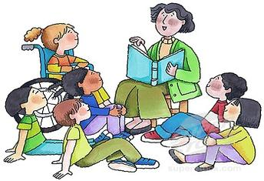List 7
Black white ten does bring goes write always drink once soon made run gave open has find only us three our better hold buy funny
List 8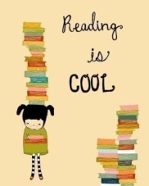
warm ate full those done use fast say light pick hurt
pull cut kind both sit which fall carry small under
read why own found
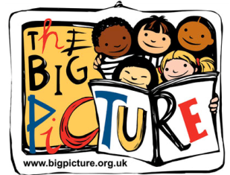List 9
wash show hot because far live draw clean grow best upon these sing together please thank wish many shall laugh

